Experiment Strats:
In the code:

A1:
A1 == 1 : Select arc with maximum M
A1 == 0 : Select based on Sk in the alg
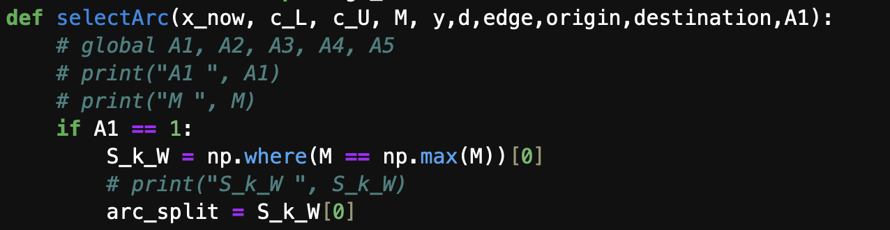

A2:

A3:
A3==0 : Split using SA if possible
A3==1 : Split mid
